**ADBS Project-2**

**MyBookStore**

**Project Name - MyBookStore**

**Semester - Fall 2020**

**Course - CS640-01 Advanced Database Systems**

**Instructor -Dr. Suhair Amer**

**Student – Venkata Avinash Gupta Chunduru Reddy**

**Student ID – S02012660**

**PROJECT DESCRIPTION**

The BookStore System aim is to design and develop a database application that contains information related to different books and users who wants to buy books from the store through online platform. It is the computerized system that helps users to buy books from anywhere and acquire all the book related information. It provides an easy graphical user Interface for the users to find specific information by performing a search operation.

**Hardware Requirements**

Processor : Intel core i7 3.5 GHz

Hard Disk : 128 GB

RAM : 8 GB.

**Software Requirements:**

Technology : XAmpp ( Apache server and MySQL database)

Data Base : MySQL

Operating system : Windows 10

**ER Diagrams:**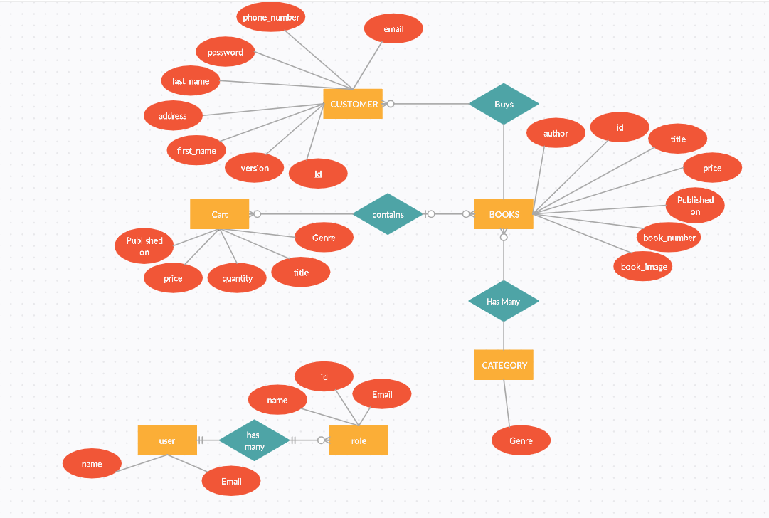

**ScreenShots of the Interfaces/UI:** 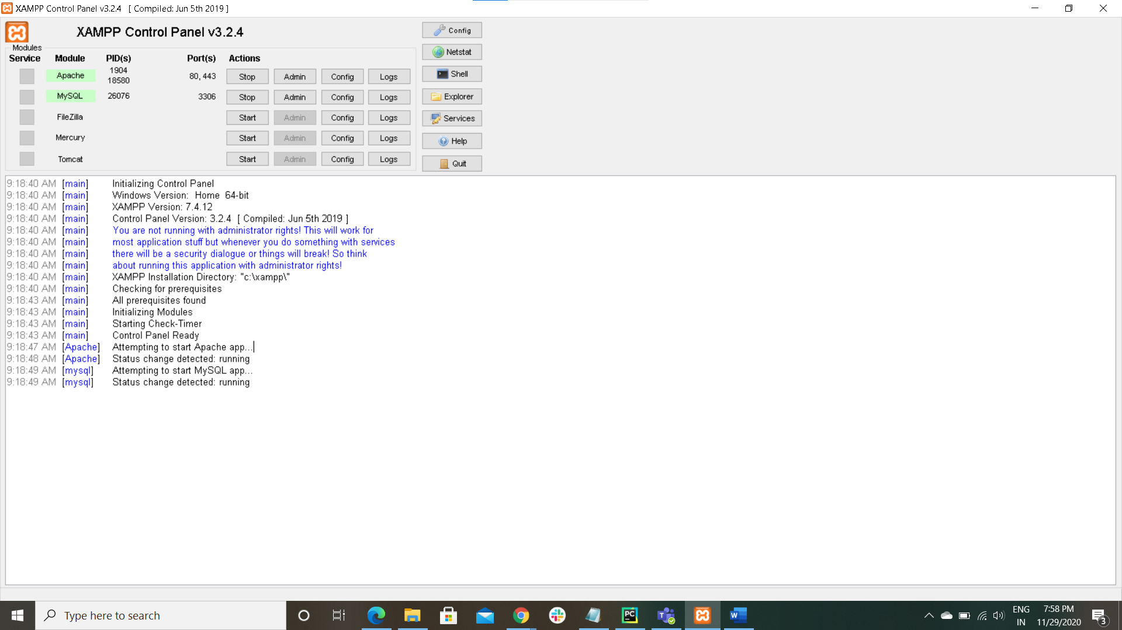

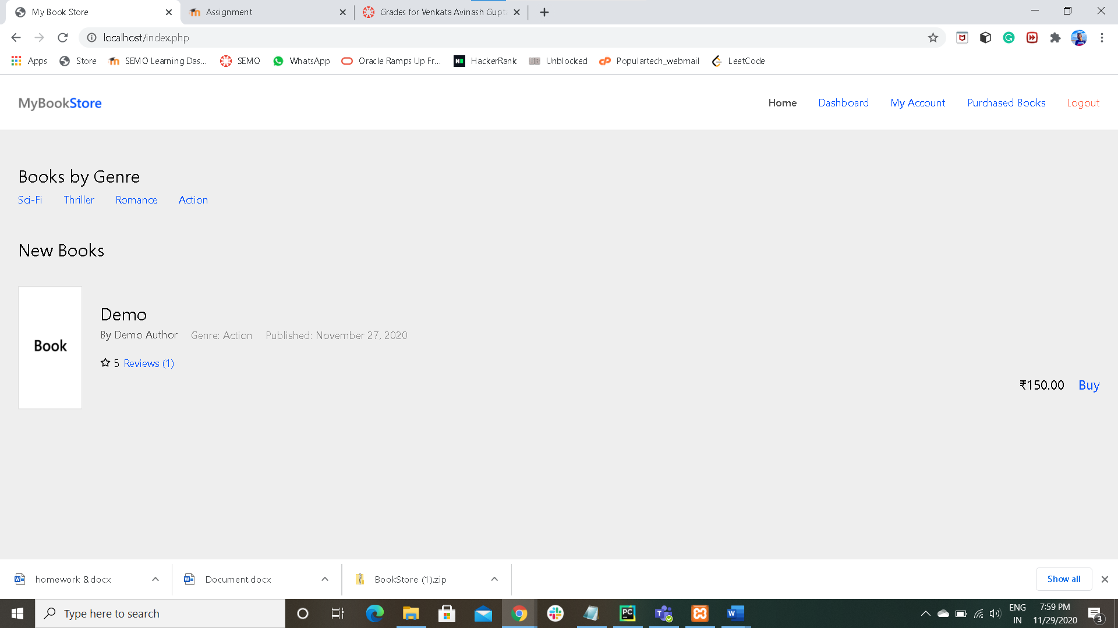

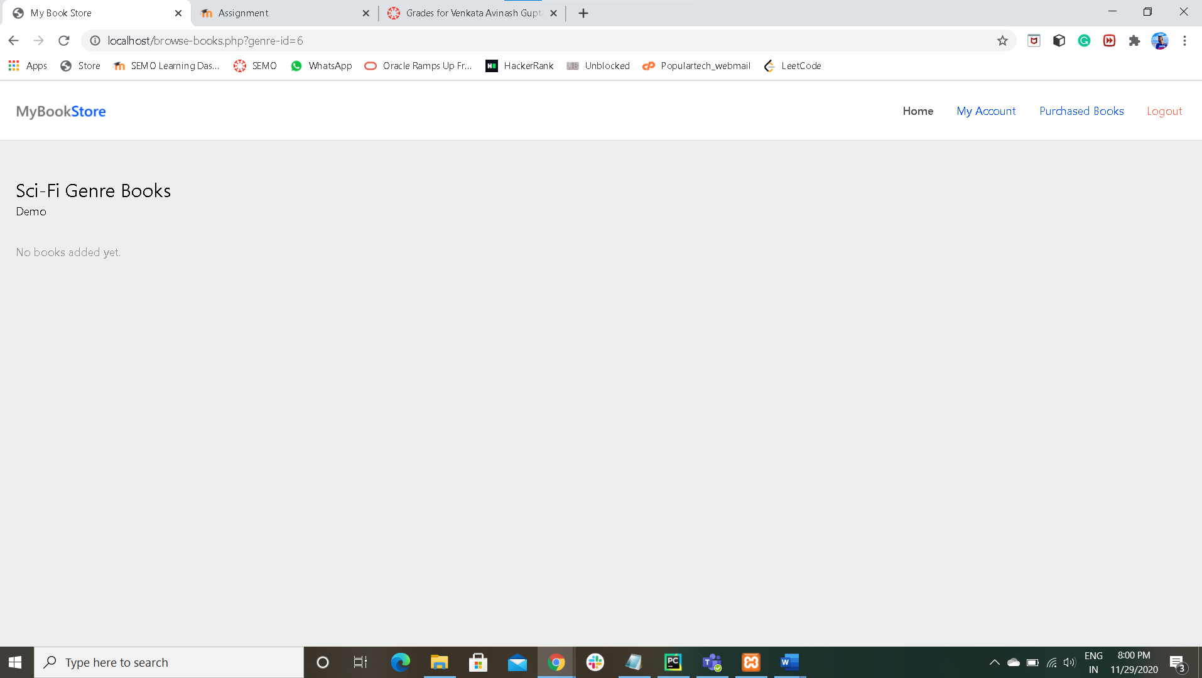

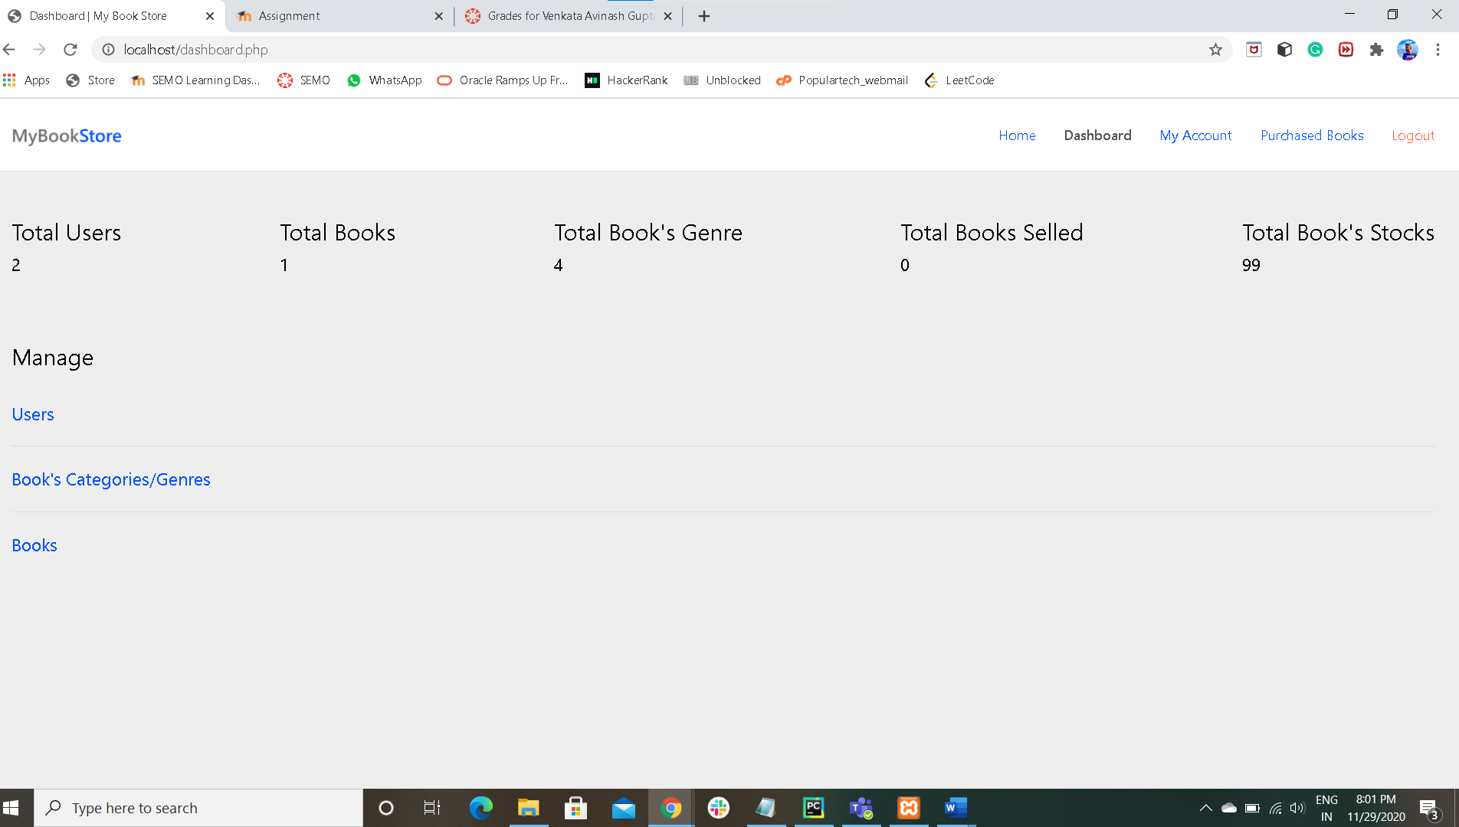

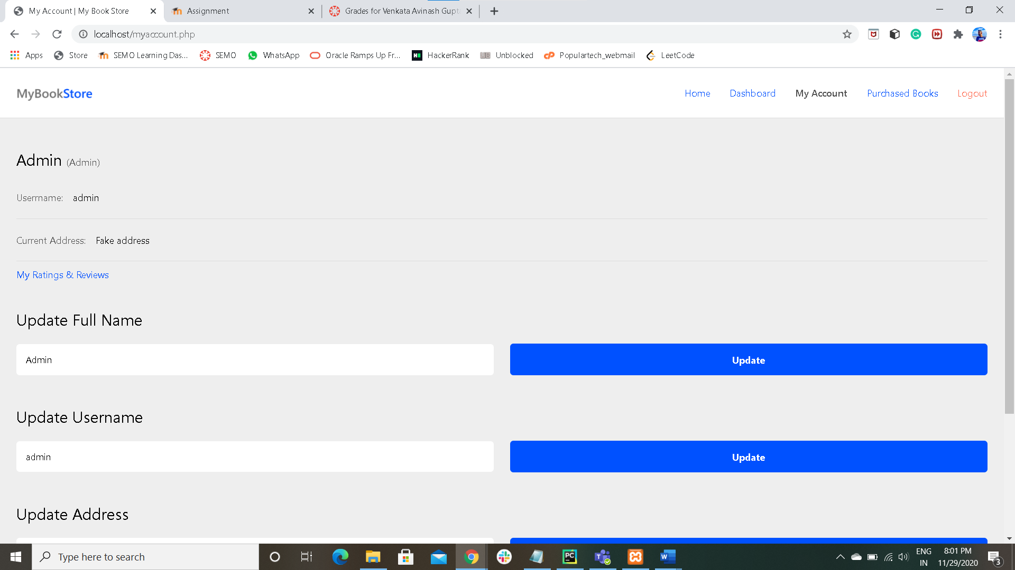

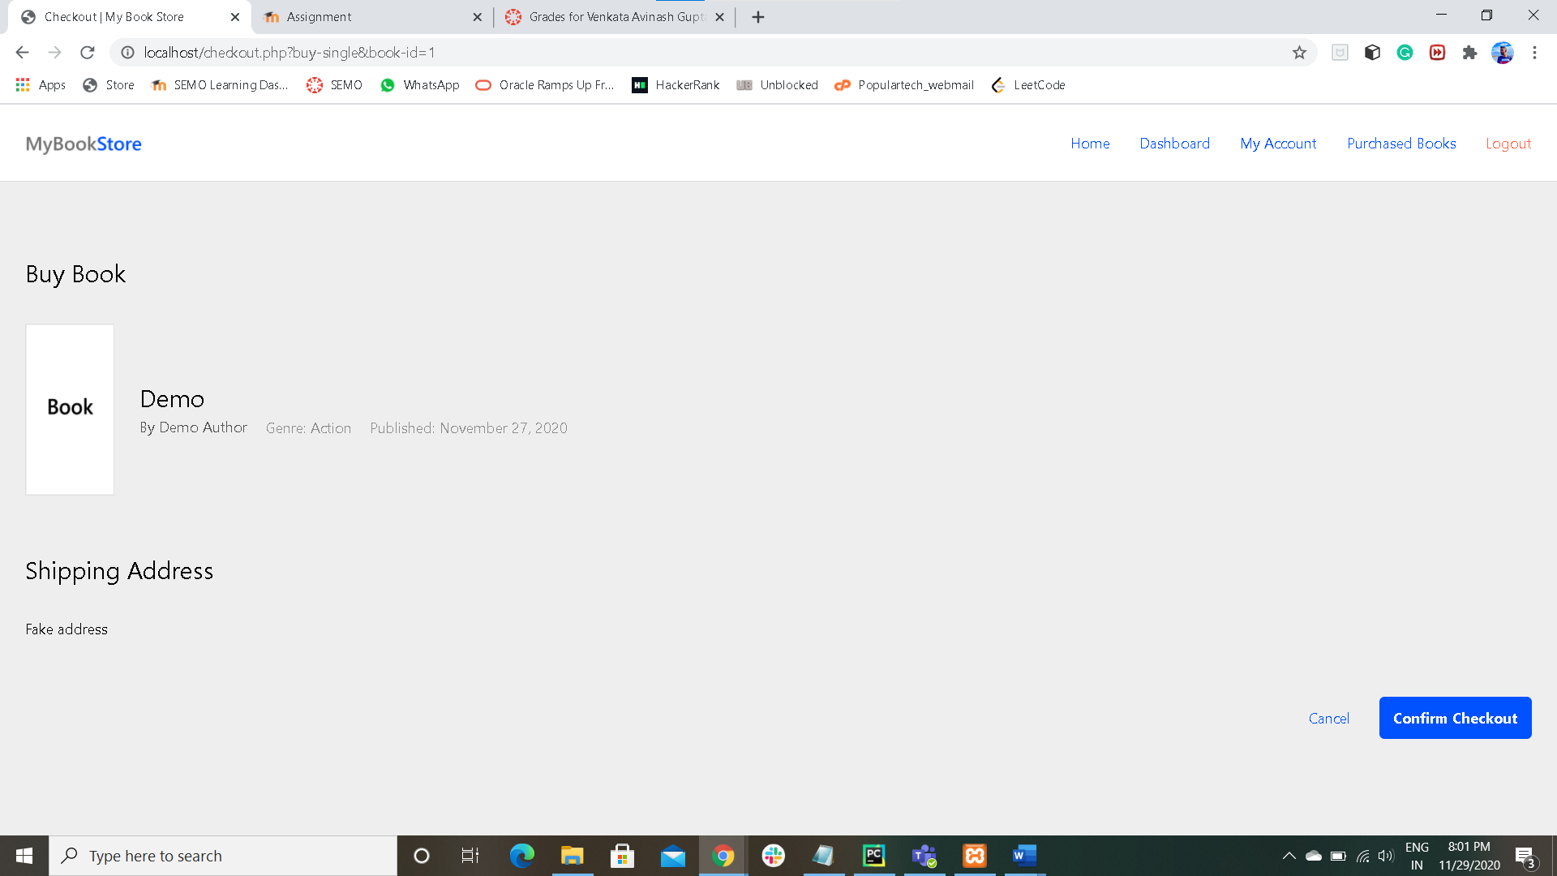

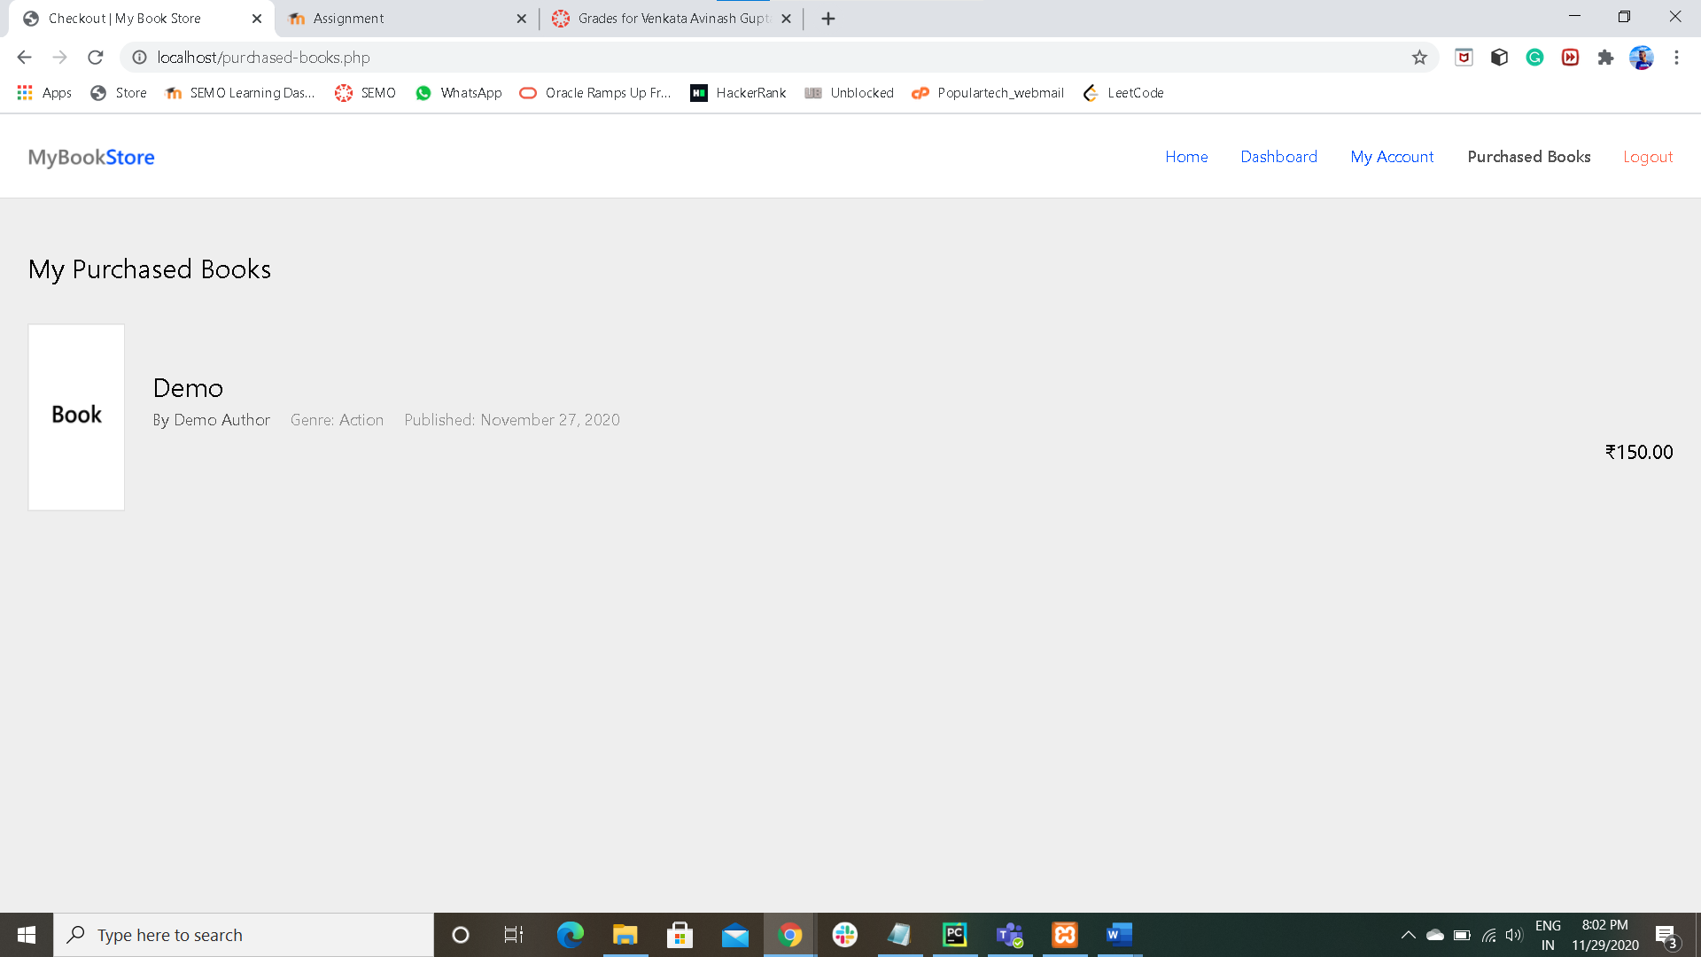

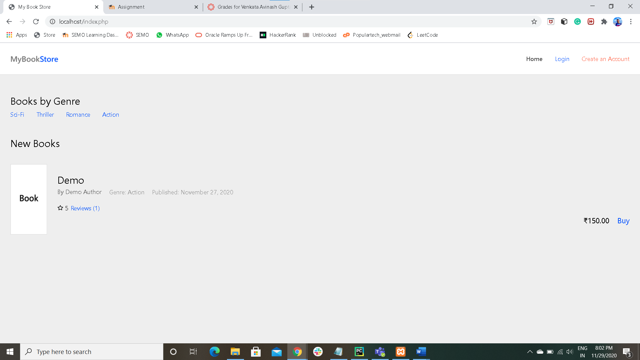

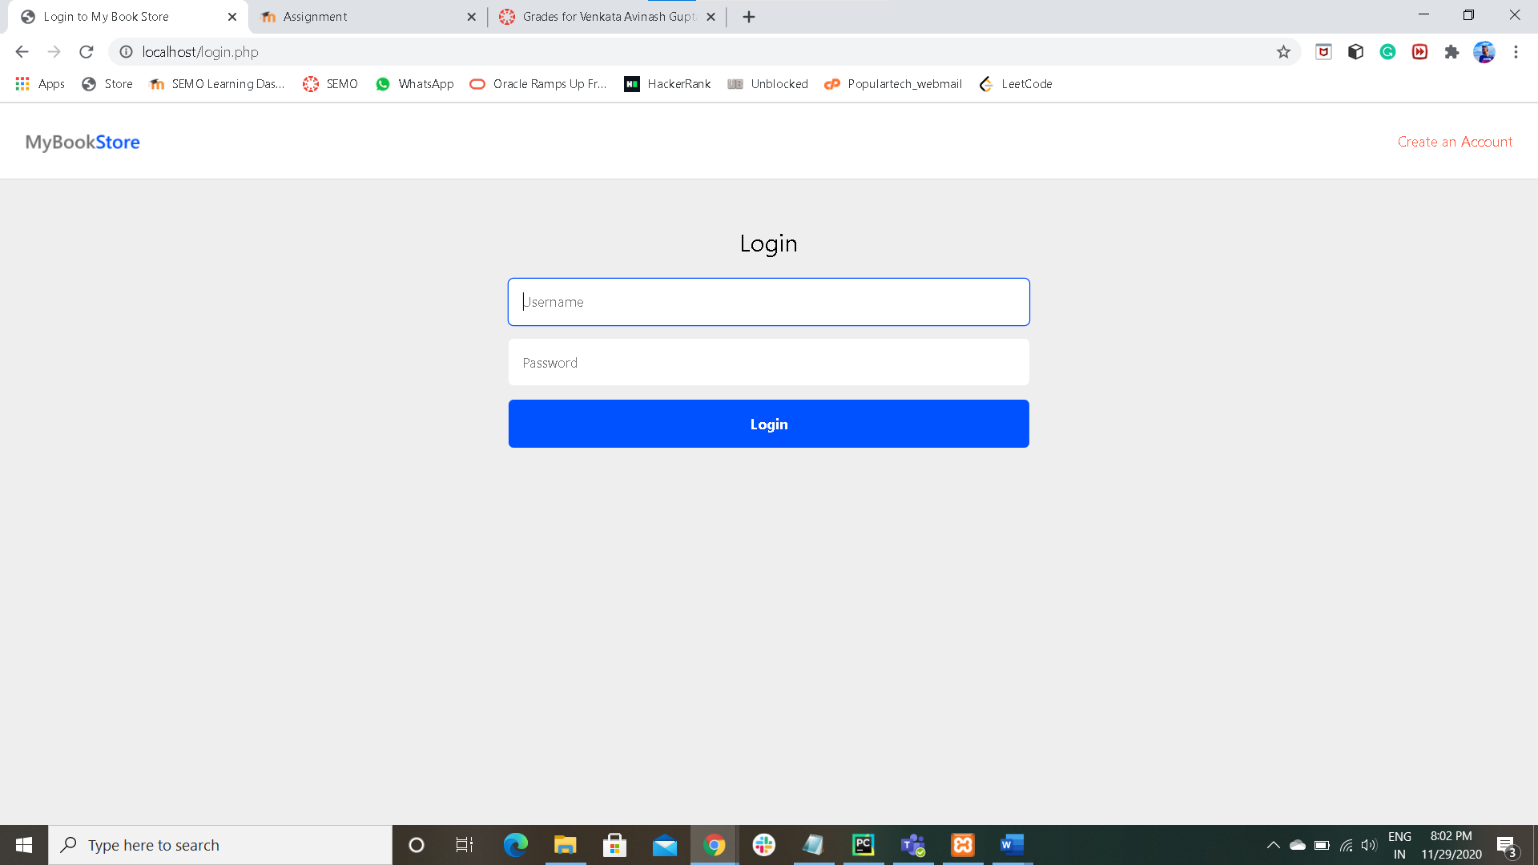

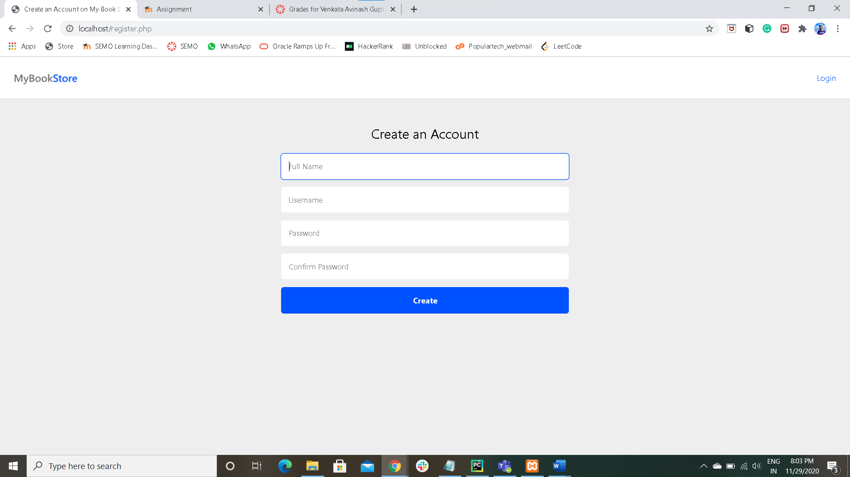

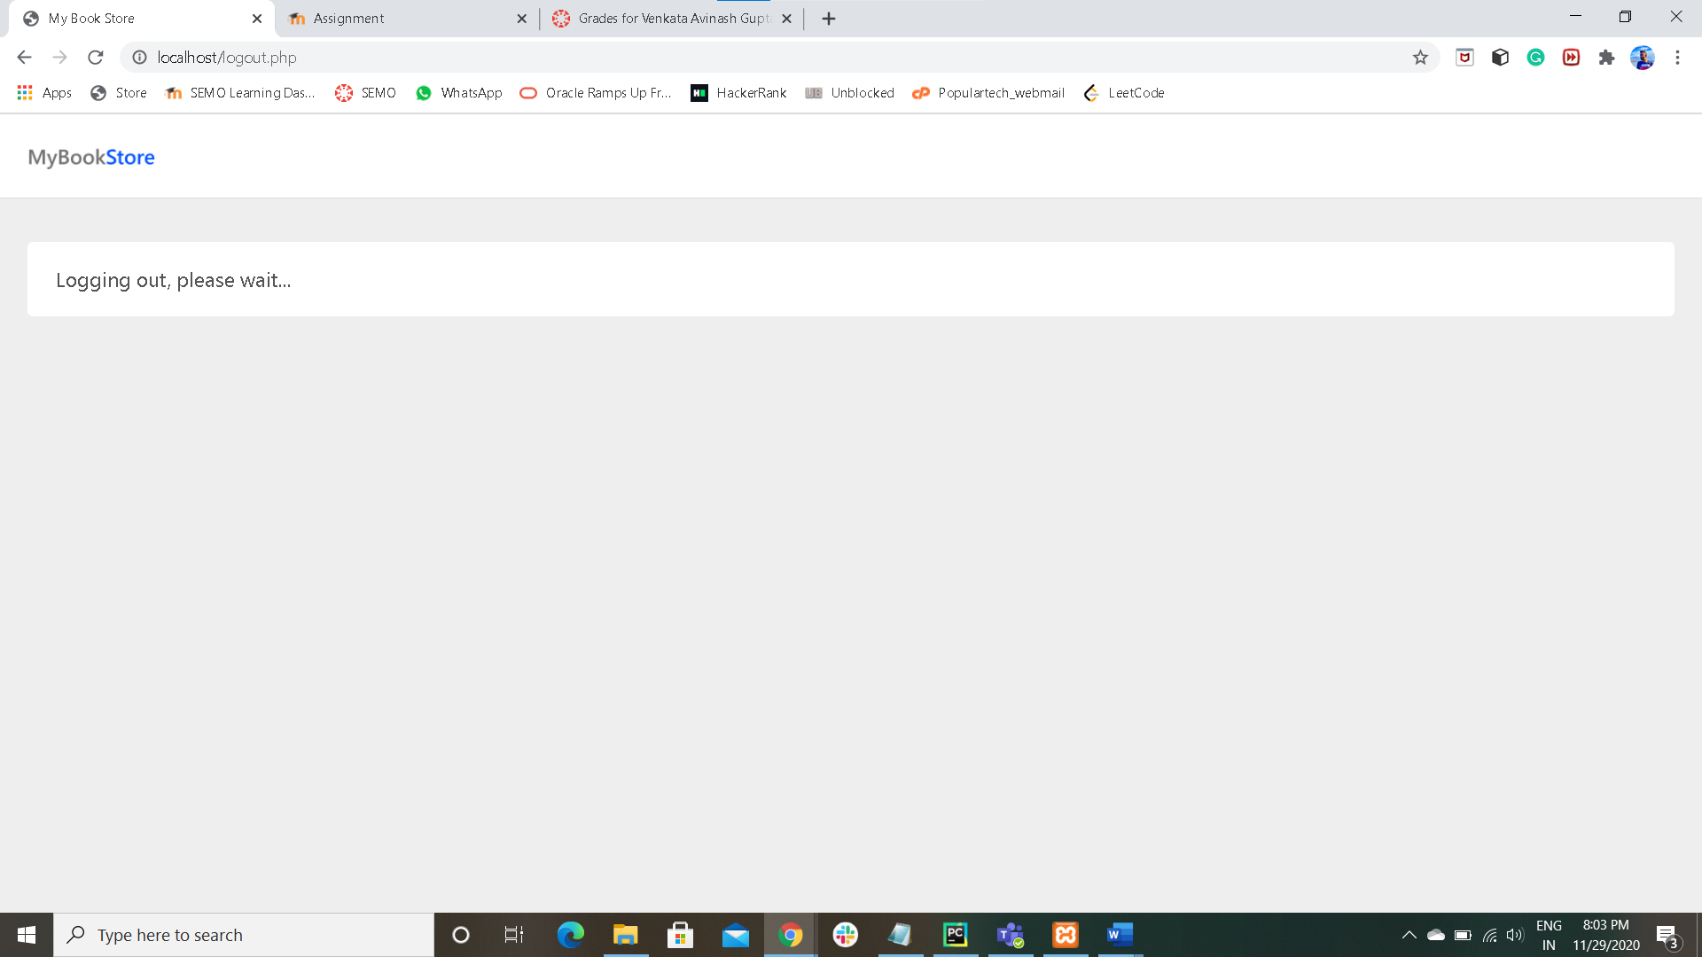

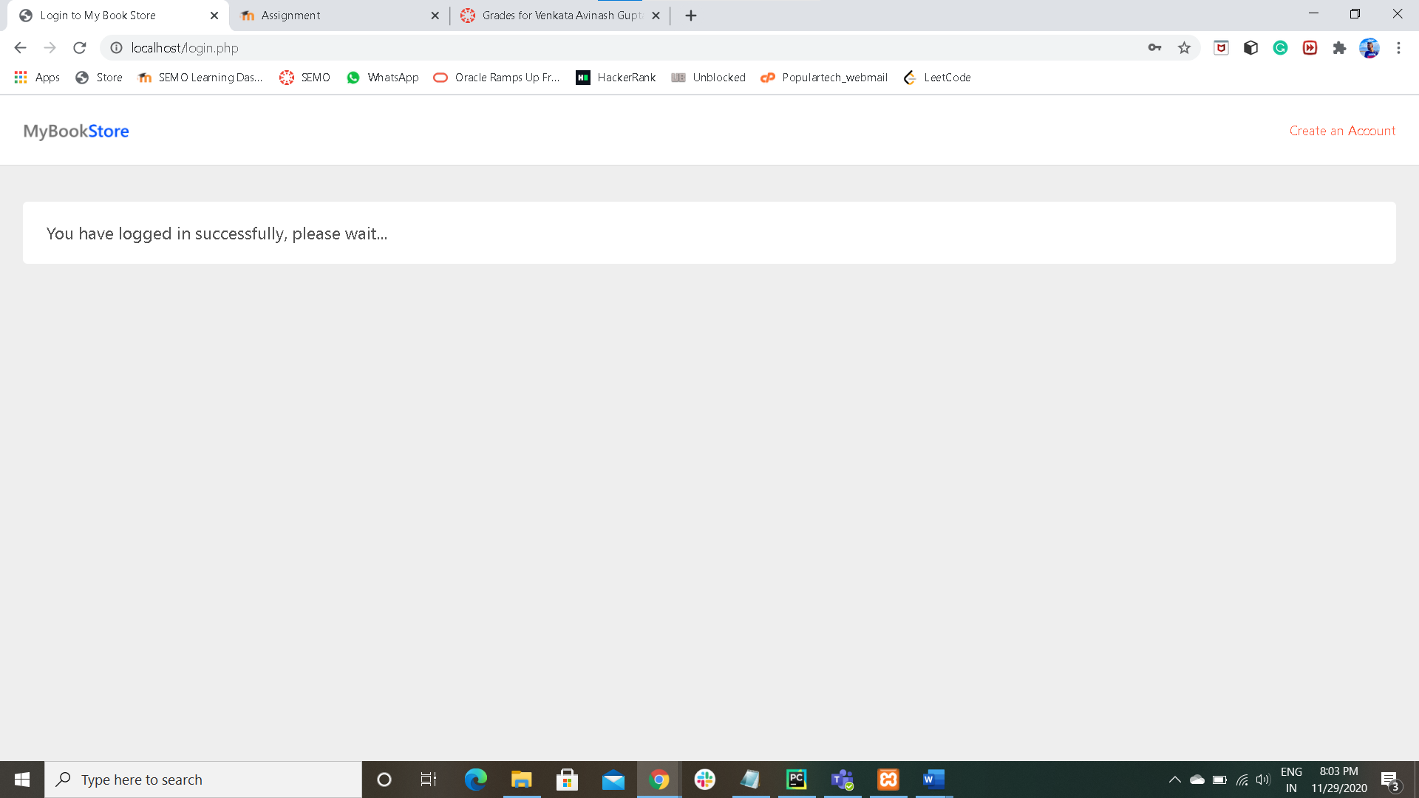

**PRINT SCREENS OF TABLES OF MYSQL** 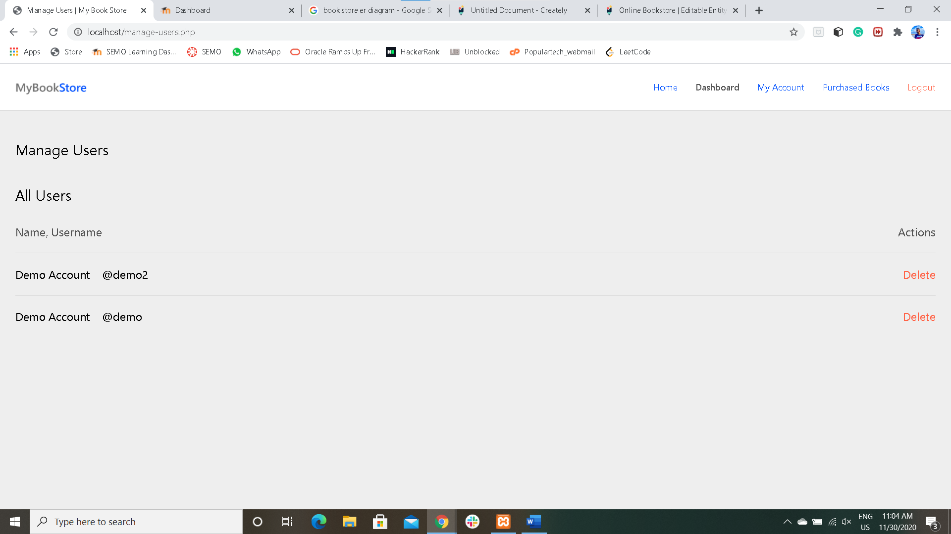

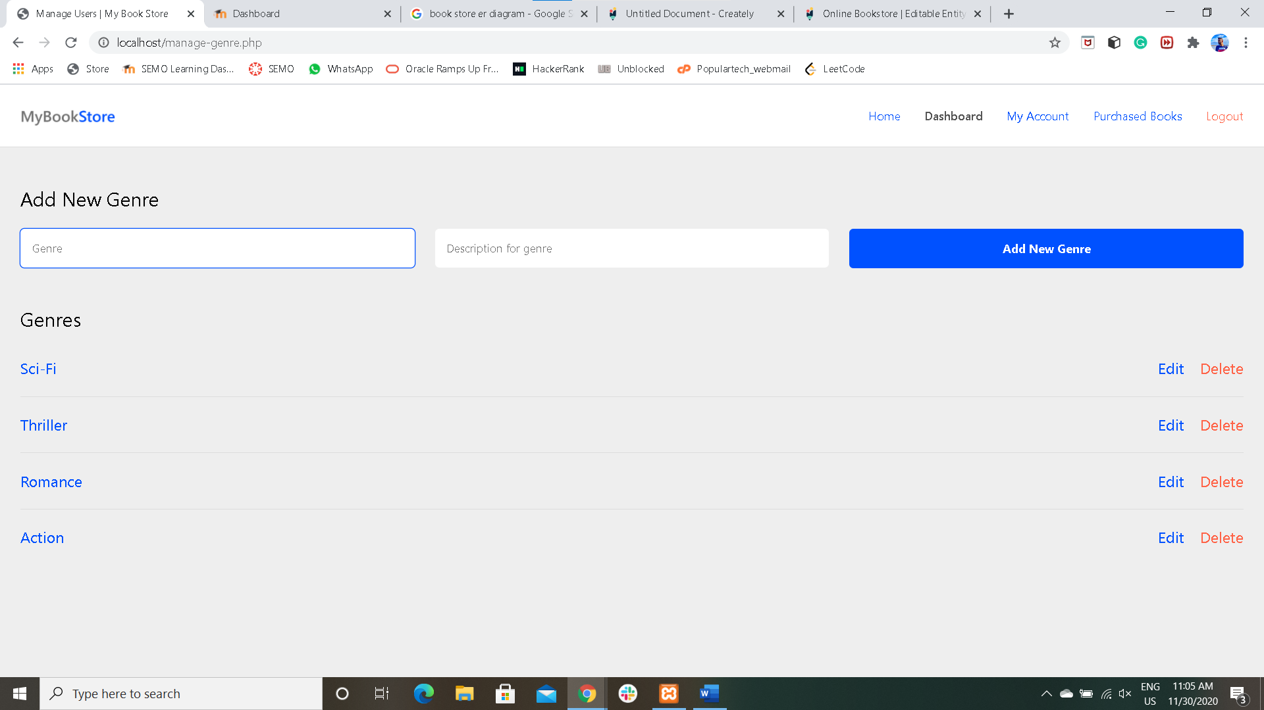

**LIST OF ALL QUERIES**

-- phpMyAdmin SQL Dump

-- version 5.0.2

-- https://www.phpmyadmin.net/

--

-- Host: 127.0.0.1

-- Generation Time: Nov 28, 2020 at 04:00 PM

-- Server version: 10.4.14-MariaDB

-- PHP Version: 7.4.9

SET SQL_MODE = "NO_AUTO_VALUE_ON_ZERO";

START TRANSACTION;

SET time_zone = "+00:00";

/*!40101 SET @OLD_CHARACTER_SET_CLIENT=@@CHARACTER_SET_CLIENT */;

/*!40101 SET @OLD_CHARACTER_SET_RESULTS=@@CHARACTER_SET_RESULTS */;

/*!40101 SET @OLD_COLLATION_CONNECTION=@@COLLATION_CONNECTION */;

/*!40101 SET NAMES utf8mb4 */;

--

-- Database: `bookstore`

--

-- --------------------------------------------------------

--

-- Table structure for table `addressbook`

--

CREATE TABLE `addressbook` (

`id` int(1) UNSIGNED NOT NULL,

`userID` int(1) UNSIGNED NOT NULL,

`address` text NOT NULL,

`addedAt` datetime DEFAULT NULL

) ENGINE=InnoDB DEFAULT CHARSET=utf8mb4;

--

-- Dumping data for table `addressbook`

--

INSERT INTO `addressbook` (`id`, `userID`, `address`, `addedAt`) VALUES

(1, 2, 'Fake addres one', '0000-00-00 00:00:00'),

(2, 1, 'Fake address', '0000-00-00 00:00:00');

-- --------------------------------------------------------

--

-- Table structure for table `books`

--

CREATE TABLE `books` (

`id` int(1) UNSIGNED NOT NULL,

`booksGenreID` int(1) UNSIGNED NOT NULL,

`bookThumbnail` text NOT NULL DEFAULT 'thumb.jpg',

`bookName` char(150) NOT NULL,

`bookAuthor` char(65) NOT NULL,

`bookPublishedOn` date DEFAULT NULL,

`bookPrice` decimal(15,2) NOT NULL DEFAULT 0.00,

`bookDescription` text NOT NULL,

`bookStockCount` int(1) UNSIGNED NOT NULL,

`bookAddedAt` datetime NOT NULL,

`bookAddedBy` int(1) UNSIGNED NOT NULL

) ENGINE=InnoDB DEFAULT CHARSET=utf8mb4;

--

-- Dumping data for table `books`

--

INSERT INTO `books` (`id`, `booksGenreID`, `bookThumbnail`, `bookName`, `bookAuthor`, `bookPublishedOn`, `bookPrice`, `bookDescription`, `bookStockCount`, `bookAddedAt`, `bookAddedBy`) VALUES

(1, 1, 'thumb.jpg', 'Demo', 'Demo Author', '2020-11-27', '150.00', 'Demo', 99, '2020-11-27 19:53:55', 1);

-- --------------------------------------------------------

--

-- Table structure for table `booksgenre`

--

CREATE TABLE `booksgenre` (

`id` int(1) UNSIGNED NOT NULL,

`genreName` char(65) NOT NULL,

`genreDescription` text NOT NULL,

`genreAddedAt` datetime DEFAULT NULL,

`genreAddedBy` int(1) UNSIGNED NOT NULL

) ENGINE=InnoDB DEFAULT CHARSET=utf8mb4;

--

-- Dumping data for table `booksgenre`

--

INSERT INTO `booksgenre` (`id`, `genreName`, `genreDescription`, `genreAddedAt`, `genreAddedBy`) VALUES

(1, 'Action', 'Demo', NULL, 1),

(4, 'Romance', 'Demo', '2020-11-28 15:58:49', 1),

(5, 'Thriller', 'Demo', '2020-11-28 15:58:58', 1),

(6, 'Sci-Fi', 'Demo', '2020-11-28 15:59:28', 1);

-- --------------------------------------------------------

--

-- Table structure for table `bookspurchased`

--

CREATE TABLE `bookspurchased` (

`id` int(1) UNSIGNED NOT NULL,

`bookID` int(1) UNSIGNED NOT NULL,

`addressID` int(1) UNSIGNED NOT NULL,

`bookPurchasedBy` int(1) UNSIGNED NOT NULL,

`bookPurchasedOn` datetime NOT NULL

) ENGINE=InnoDB DEFAULT CHARSET=utf8mb4;

-- --------------------------------------------------------

--

-- Table structure for table `booksrating`

--

CREATE TABLE `booksrating` (

`id` int(1) UNSIGNED NOT NULL,

`bookID` int(1) UNSIGNED NOT NULL,

`rating` tinyint(5) NOT NULL DEFAULT 1,

`comment` text NOT NULL,

`ratedBy` int(1) UNSIGNED NOT NULL

) ENGINE=InnoDB DEFAULT CHARSET=utf8mb4;

--

-- Dumping data for table `booksrating`

--

INSERT INTO `booksrating` (`id`, `bookID`, `rating`, `comment`, `ratedBy`) VALUES

(3, 1, 5, 'demo', 8);

-- --------------------------------------------------------

--

-- Table structure for table `users`

--

CREATE TABLE `users` (

`id` int(1) UNSIGNED NOT NULL,

`fullName` char(65) NOT NULL,

`username` char(25) NOT NULL,

`password` char(65) NOT NULL,

`userRole` enum('admin','user') NOT NULL DEFAULT 'user',

`accountCreatedAt` datetime DEFAULT NULL

) ENGINE=InnoDB DEFAULT CHARSET=utf8mb4;

--

-- Dumping data for table `users`

--

INSERT INTO `users` (`id`, `fullName`, `username`, `password`, `userRole`, `accountCreatedAt`) VALUES

(1, 'Admin', 'admin', 'admin', 'admin', '2020-11-27 20:17:40'),

(2, 'Demo Account', 'demo', '1234', 'user', '2020-11-27 20:21:01'),

(8, 'Demo Account', 'demo2', 'demo', 'user', '2020-11-27 20:22:47');

--

-- Indexes for dumped tables

--

--

-- Indexes for table `addressbook`

--

ALTER TABLE `addressbook`

ADD PRIMARY KEY (`id`),

ADD KEY `userID` (`userID`);

--

-- Indexes for table `books`

--

ALTER TABLE `books`

ADD PRIMARY KEY (`id`),

ADD KEY `booksGenreID` (`booksGenreID`),

ADD KEY `bookName` (`bookName`),

ADD KEY `bookStockCount` (`bookStockCount`),

ADD KEY `bookAddedBy` (`bookAddedBy`),

ADD KEY `bookThumbnail` (`bookThumbnail`(768));

--

-- Indexes for table `booksgenre`

--

ALTER TABLE `booksgenre`

ADD PRIMARY KEY (`id`),

ADD KEY `genreName` (`genreName`),

ADD KEY `genreAddedBy` (`genreAddedBy`);

--

-- Indexes for table `bookspurchased`

--

ALTER TABLE `bookspurchased`

ADD PRIMARY KEY (`id`),

ADD KEY `bookID` (`bookID`),

ADD KEY `bookPurchasedBy` (`bookPurchasedBy`),

ADD KEY `addressID` (`addressID`);

--

-- Indexes for table `booksrating`

--

ALTER TABLE `booksrating`

ADD PRIMARY KEY (`id`),

ADD KEY `bookID` (`bookID`),

ADD KEY `ratedBy` (`ratedBy`);

--

-- Indexes for table `users`

--

ALTER TABLE `users`

ADD PRIMARY KEY (`id`),

ADD UNIQUE KEY `username` (`username`),

ADD KEY `userRole` (`userRole`),

ADD KEY `password` (`password`);

--

-- AUTO_INCREMENT for dumped tables

--

--

-- AUTO_INCREMENT for table `addressbook`

--

ALTER TABLE `addressbook`

MODIFY `id` int(1) UNSIGNED NOT NULL AUTO_INCREMENT, AUTO_INCREMENT=3;

--

-- AUTO_INCREMENT for table `books`

--

ALTER TABLE `books`

MODIFY `id` int(1) UNSIGNED NOT NULL AUTO_INCREMENT, AUTO_INCREMENT=4;

--

-- AUTO_INCREMENT for table `booksgenre`

--

ALTER TABLE `booksgenre`

MODIFY `id` int(1) UNSIGNED NOT NULL AUTO_INCREMENT, AUTO_INCREMENT=7;

--

-- AUTO_INCREMENT for table `bookspurchased`

--

ALTER TABLE `bookspurchased`

MODIFY `id` int(1) UNSIGNED NOT NULL AUTO_INCREMENT;

--

-- AUTO_INCREMENT for table `booksrating`

--

ALTER TABLE `booksrating`

MODIFY `id` int(1) UNSIGNED NOT NULL AUTO_INCREMENT, AUTO_INCREMENT=5;

--

-- AUTO_INCREMENT for table `users`

--

ALTER TABLE `users`

MODIFY `id` int(1) UNSIGNED NOT NULL AUTO_INCREMENT, AUTO_INCREMENT=10;

--

-- Constraints for dumped tables

--

--

-- Constraints for table `addressbook`

--

ALTER TABLE `addressbook`

ADD CONSTRAINT `userID_address` FOREIGN KEY (`userID`) REFERENCES `users` (`id`) ON DELETE CASCADE ON UPDATE CASCADE;

--

-- Constraints for table `books`

--

ALTER TABLE `books`

ADD CONSTRAINT `bookAddedBy` FOREIGN KEY (`bookAddedBy`) REFERENCES `users` (`id`) ON DELETE CASCADE ON UPDATE CASCADE,

ADD CONSTRAINT `bookGenreID` FOREIGN KEY (`booksGenreID`) REFERENCES `booksgenre` (`id`) ON DELETE NO ACTION ON UPDATE CASCADE;

--

-- Constraints for table `booksgenre`

--

ALTER TABLE `booksgenre`

ADD CONSTRAINT `genreAddedBy` FOREIGN KEY (`genreAddedBy`) REFERENCES `users` (`id`) ON DELETE CASCADE ON UPDATE CASCADE;

--

-- Constraints for table `bookspurchased`

--

ALTER TABLE `bookspurchased`

ADD CONSTRAINT `addressID_purchased` FOREIGN KEY (`addressID`) REFERENCES `addressbook` (`id`) ON DELETE CASCADE ON UPDATE CASCADE,

ADD CONSTRAINT `bookID_purchased` FOREIGN KEY (`bookID`) REFERENCES `books` (`id`) ON DELETE CASCADE ON UPDATE CASCADE,

ADD CONSTRAINT `userID_purchased` FOREIGN KEY (`bookPurchasedBy`) REFERENCES `users` (`id`) ON DELETE CASCADE ON UPDATE CASCADE;

--

-- Constraints for table `booksrating`

--

ALTER TABLE `booksrating`

ADD CONSTRAINT `bookID_rating` FOREIGN KEY (`bookID`) REFERENCES `books` (`id`) ON DELETE CASCADE ON UPDATE CASCADE,

ADD CONSTRAINT `userID_rating` FOREIGN KEY (`ratedBy`) REFERENCES `users` (`id`) ON DELETE CASCADE ON UPDATE CASCADE;

COMMIT;

/*!40101 SET CHARACTER_SET_CLIENT=@OLD_CHARACTER_SET_CLIENT */;

/*!40101 SET CHARACTER_SET_RESULTS=@OLD_CHARACTER_SET_RESULTS */;

/*!40101 SET COLLATION_CONNECTION=@OLD_COLLATION_CONNECTION */;

**CONCLUSION**

I learned a lot of things related to project planning and implementation while working on the Bookstore Project. This project has given lot of practical knowledge and real time work experience. I have not dealt with the tools and programming languages that I used to build the Bookstore system, so I have faced few problems with setting up the environment and beginning the project. But later, as I started working the workflow was smooth. The ER diagrams were of great help to carry out the project smoothly and work on each module without any ambiguity. I spent about month to complete the project. In the initial weeks I have analyzed the projects requirement and evaluated which programming languages and tools would be best to implement this project. Then I have drawn the ER diagrams to get a clear picture of the project and then I have setup the environment for the implementation. Later I started implementing each module after creating the tables and then tested it to ensure the module is working as per the requirements. Finally, I have created a GUI for the Bookstore system and made it possible for the admin and the user to insert and view the information related to the books respectively. The overall experience was great as it has given an example of how real time projects can be dealt and I also got to learn few new things related to the programming languages and tools.